Comprehensive English for Graduates

2nd semester, 2024-2025

Time: Week 8-10

Venue: L3 714 Zhili Bld

# Lecture 4

## Unit 5 Text A

### Additional information

1. Aristotle

an ancient Greek philosopher

a student of Plato

the teacher of Alexander the Great

Socrates

1. David Cameron

Prime Minister of UK (2010-2016)

Final speech as Prime Minister

<https://www.metatube.com/en/videos/312942/David-Camerons-Final-Speech-As-PM>

1. The Enlightenment

Please refer to notes of the text.

1. Renaissance

a. The humanistic revival of classical art, architecture, literature,  and learning that originated in Italy in the 14th century and later  spread throughout Europe.

**b**. The period of this revival, roughly the 14th through the 16th century, marking the transition from medieval to modern times.

### Understanding the text

#### Paragraph 1

1. What is the function of this paragraph to the article as a whole?
2. What is the key word in S1?
3. What are the problems in the developed countries and in what way are the problems presented?

Problems that are not quantifiable:

Quantifiable problems:

1. Translating
2. well-being
3. defined relationships
4. unparalleled liberty
5. midlife crisis

#### Paragraph 2-3

1. What is the goal of life according to Aristotle?
2. How did Robert Kennedy interpret happiness?
3. What do people respond to the question of happiness?
4. Translating
5. The politics of happiness is nothing new.

探讨幸福的内涵古已有之。

1. beautifully crafted 言辞精妙

#### Paragraph 4

1. What are the reasons and in what way are they presented?
2. Two major political parties in UK

Conservative Party. The Conservative Party has a centre-right position in UK's politics

Labour Party. The Labour Party occupies a centre-left position in UK's politics

1. Electoral cycle in UK

Every 5 years

1. Translating

... it is notoriously difficult subject...to grasp

政治家们还是难以理解这一众所周知的难题---幸福的确切内涵。

1. a culture of short-termism 急功近利的氛围
2. immediate, quantifiable measurements and results

立竿见影的，量化的测量手段和结果

#### Paragraph 5

1. What is the measurement?

GDP gross domestic product

GNP gross national product

1. What were the economic problems in the 1980s?
2. Translating
3. Center-right political parties 中-右派
4. We got that. 我们找到了解决问题的方法。

#### Paragraph 6-7

1. What is Cameron’s argument?
2. What does GWB mean?
3. Why does the author use the same sentence pattern “It means...”?
4. Translating
5. GWB
6. the champions of this cause
7. units of account
8. ...to be just as revolutionary to put us back on track..为

了重新回到社会繁荣昌盛的轨道上：积极响应对幸福的追求，我们需要如同当时一样彻底改变思想。

1. it cannot be delivered simply by the push of a

legislator’s pen.通过立法也不能实现个人的身心健康。

#### Paragraph 8-9

1. What is sharing responsibility?
2. What is the government’s role?
3. Translating
4. S2/p8 这需要更广泛的文化变革：在立法，领导方式以

及社会等各方面变革之后，才能引起这场大的变革。

1. Here governments......那么在这方面政府应该率先公务

员灵活机动的工作时间。

#### Paragraph 10

1. What is the government’s framework?
2. What is the most important concern?
3. Translating
4. Setting the right framework means creating incentives

and removing barriers to remodel the context within which the whole society makes changes. 制定恰当的规章制度是指建立激励机制并排除障碍重建社会体系，这样整个社会依次作出选择。

#### Paragraph 11

1. Corporate responsibility
2. Civic responsibility
3. Personal responsibility

#### Paragraph 12

1. Translating

Rather......相反，既然我们政治上已经更加自由，经

济更加繁荣发展，文化更加百花齐放，那么我们的生活能够而且应该更加令人满意。

### Writing

#### Objective

The objective is to develop skills to write two paragraphs (150 words) where you describe a line graph using past tense verbs.

#### A line graph with information provided for trend

This type of line graph usually consists of three parts, information on top of the graph which presents the theme, information on the y axis , which represents how it is measured, and information on the x axis showing the time. Therefore, before you describe a line graph, please

1. identify the information provided in the line graph;
2. look at the graph and identify the components; and
3. identify the numbers of each component.

#### How to describe a line graph

1. The opening sentence

The line graph shows /illustrates ......

1. Change the information provided in the graph

Normally you start by repeating information on top of the graph and then information on the y axis including the way it is measured. Then you should include the information on the x axis of the graph.

1. Words and phrases necessary for describing a line graph

overall/in general

Increase/decrease rise/fall/drop remain unchanged

sharply/slightly/significantly/gradually/consistently

#### Steps for description

1. Opening
2. Overall description
3. Description in details

#### Sentences structures and tense

1. Complex sentences with attributive clause are strongly

recommended for describing a line graph. Therefore, you are not advised to use too many simple sentences, instead you can combine two simple sentences into one complex sentence.

1. Present tense is used for the first verb in the opening

sentence, while past tense should be used for the description, although perfect tense is advised.

1. In addition, always pay attention to the subject-verb

agreement.

1. Comparative degree should be used when there are two

lines in the graph.

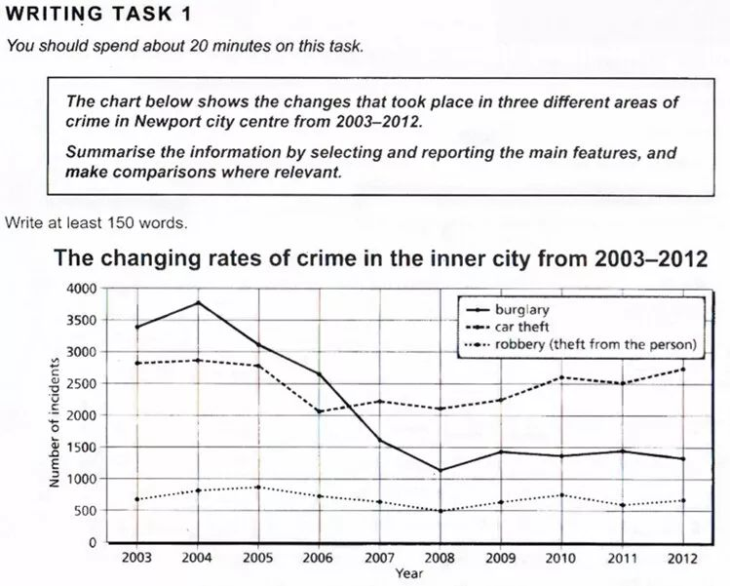

### Topic for Speaking

1. What languages can you speak?
2. Do you think it’s difficult to learn a new language?
3. Will you learn other languages in the future?
4. Why do you learn English?

## **Samples**

1. What languages can you speak?

　　Well, I can speak Mandarin, Cantonese and some English. Yeah, only some English. It’s not that I’m not familiar with English. I actually started to learn English when I was four or five years old. I can understand English when its spoken to me, and I read English magazines. However, speaking is never something I’ve been good at. In fact, I only started to speak English in recent years.

1. Do you think it’s difficult to learn a new language?

I think it’s difficult to truly master a language, yeah. I say so out of personal experience. A couple of years ago, I signed up for Spanish lessons. The beginning of it was so easy and interesting.However, I couldn’t carry on after two months when I had to make that weird tongue-twisting sound. Yeah, I was embarrassed to make that sound. I quit it. So no, I don’t think it’s easy to learn a new language.

1. Will you learn other languages in the future?

　　 I might. Yeah, it’s possible that I may have to learn new languages at some point, especially Japanese because my sister has moved to Japan. She has been granted permanent residency. We are very close, and I do plan to visit her often in the future. So, I may take Japanese lessons in the future, just so I can enjoy my stay there.

1. Why do you learn English?

I chose to learn English because learning a language gives me a lot of satisfaction. I enjoy learning it, and I know that every hour I spend gets me closer to perfection. Besides, by learning English, I also learn about other cultures. Few experiences will make me grow as a person more than learning the values, habits and way of life in a culture that is different from mine.

## Text B

### Topics for discussion in relation to the essay

1. What does the true calling mean?
2. Do you agree with the author’s opinion that excellence is a journey, not a destination? How do you understand it?
3. Do you feel inspired after reading the essay, as the author is addressed to you?

### Understanding the text

#### Paragraph 1-2

1. Topic of the essay

How does the author present the topic to be discussed in

the essay? By an issue or a problem.

#### Paragraph 3-4

1. Reasons and results for unsuccessful people.
2. Translating
3. ...who have not taken the time...没有踏踏实实地坐下来

坦诚地认识了解自我。

1. They have not looked deep within...他们没有深刻地审

视自己。充分认识到生命中展示出的宝贵才华和能力。

#### Paragraph 5

1. Topic sentence: S1
2. Translating

S1 将自己的能力发挥到至极，充分展现自我才华和能力。

#### Paragraph 6

1. Topic sentence S1

#### Paragraph 7-8

1. Excellence is a journey, not a destination.
2. What do successful people know?

* The other paragraphs in this essay contain the author’s suggestions for becoming successful in the professional career.